English division – 1st year 2016/2017
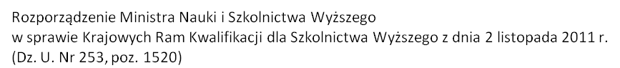
Plan of Study
for the students of 6 year MD Program
in the academic year 2016/2017

 | Faculty: THE FACULTY OF MEDICINE AND HEALTH SCIENCES
 | Field of study: MEDICINE
 |  |  |  |  |  | Distribution of hours
No. | Subject | code | kind of assesment in semester |  |  | First Year
 |  |  |  |  |  | 1st semester
 |  |  | E | Credit with grade | Pass | Lecture | Tutorial | Practical classes | Laboratory | Hours | ECTS
 |  |  |  |  |  | cont. | cont. | cont. | cont.
1.MODULE Morphological Sciences
1,1 | Anatomy | 12.6-3LEK-B1,1-A | 2 | 1,2 |  | 40 | 30 | 45 |  | 115 | 10
2.MODULE Scientific basis of medicine
2.2. | Basis of cell biology | 12.6-3LEK-B.2-BBK | 2 | 2 |  | 30 |  |  | 60 | 90 | 6
2,3 | Chemistry | 12.6-3LEK-B2,3-C | 1 | 1 |  | 15 |  |  | 30 | 45 | 4
2,8 | Biostatistic with elements of informatics | 12.6-3LEK-B2,8-BzEI | 2 | 1,2 |  | 15 | 35 |  |  | 50 | 3
4. MODULE Behavioral sciences with elements of professionalism
4,1 | Medical Sociology | 12.6-3LEK-B4,1-MS |  | 2 |  | 15 |  |  |  | 15 | 1
4,3 | Ethics | 12.6-3LEK-B4,3-E |  | 1 |  | 15 |  |  |  | 15 | 1
4,4 | Elements of professionalism | 12.6-3LEK-B4,4-EP |  | 1 |  | 15 |  |  |  | 15 | 1
4,5 | Basic Polish | 12.6-3LEK-B4,5-BE | 4 | 1,2,3,4 |  |  | 50 |  |  | 50 | 2
4,8 | Latin | 12.6-3LEK-B4,8-JŁ |  | 1 |  |  | 30 |  |  | 30 | 1
5. MODULE Clinical Sciences - Non-surgical treatment
10. MODULE Univeristy-wide module
10,2 | Library Information | 12.6-3LEK-A10,2-PB |  |  | 1 |  | 2 |  |  | 2 | 0
10,3 | Elements of Health and Safety at Work and Ergonomics | 12.6-3LEK-A10,3-BHP |  |  | 1 | 5 |  |  |  | 5 | 0

